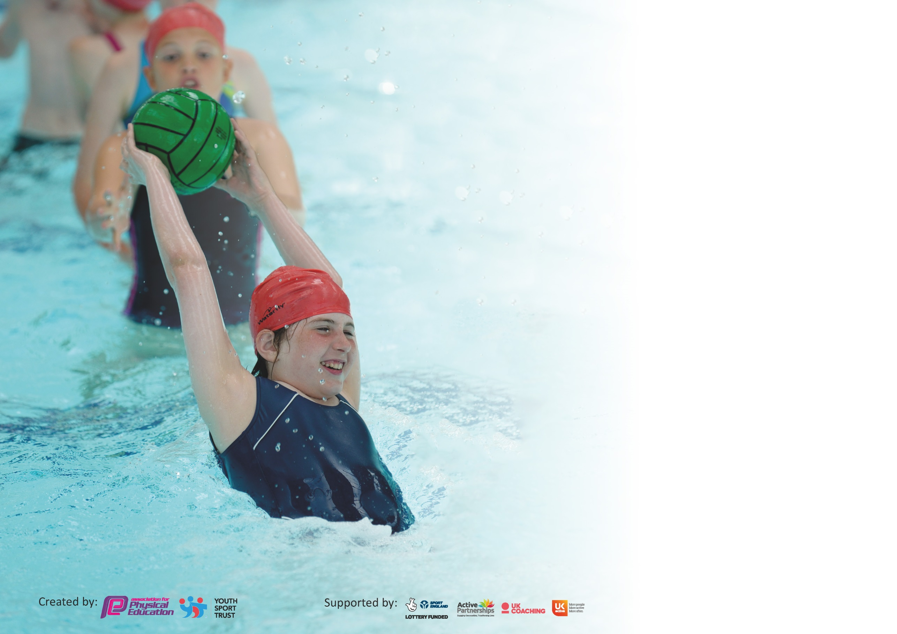

It is important that your grant is used effectively and based on school need. The Education Inspection Framework (Ofsted 2019 p64) makes clear there will be a focus on ‘whether leaders and those responsible for governors all understand their respective roles and perform these in a way that enhances the effectiveness of the school’.

Under the Quality of Education criteria (p41) inspectors consider the extent to which schools can articulate their curriculum (INTENT), construct their curriculum (IMPLEMENTATION) and demonstrate the outcomes which result (IMPACT).

To assist schools with common transferable language this template has been developed to utilise the same three headings which should make your plans easily transferable between working documents.

Schools must use the funding to make additional and sustainable improvements to the quality of Physical Education, School Sport and Physical Activity (PESSPA) they offer. This means that you should
use the Primary PE and Sport Premium to:

- Develop or add to the PESSPA activities that your school already offer
- Build capacity and capability within the school to ensure that improvements made now will benefit pupils joining the school in future years

Please visit gov.uk for the revised DfE guidance including the 5 key indicators across which schools should demonstrate an improvement. This document will help you to review your provision and to report your spend. DfE encourages schools to use this template as an effective way of meeting the reporting requirements of the Primary PE and Sport Premium.

We recommend you start by reflecting on the impact of current provision and reviewing the previous spend.

Schools are required to publish details of how they spend this funding as well as on the impact it has on pupils’ PE and sport participation and attainment by the end of the summer term or by 31st July 2020 at the latest.

We recommend regularly updating the table and publishing it on your website throughout the year. This evidences your ongoing self-evaluation of how you are using the funding to secure maximum, sustainable impact. Final copy must be posted on your website by the end of the academic year and no later than the 31st July 2020. To see an example of how to complete the table please click HERE.

Support for review and reflection - considering the 5 key indicators from DfE, what development needs are a priority for your setting and your pupils now and why? Use the space below to reflect on previous spend and key achievements and areas for development.

Key achievements to date until July 2019: | Areas for further improvement and baseline evidence of need:
Raising profile of PE throughout the school  Raising the profile of PE outside the school (with parents) via word of mouth and through social media use  Attending high percentage of School Sport events, especially those involving Year 6.  Reaching Year 6 county play off finals for the second year running in basketball  Year 6 winning the swimming gala. | Pupil perception survey required for all year groups to ascertain level of understanding and areas for improvement in PE  Ensure equipment and resources are in place for the start of 20-21  Introduce volley ball once pitches built.  Become involved with our local school games organiser to be a part of their health members campaign.

Meeting national curriculum requirements for swimming and water safety.
What percentage of your current Year 6 cohort swim competently, confidently and proficiently over a distance of at least 25 metres?  N.B. Even though your pupils may swim in another year please report on their attainment on leaving  primary school at the end of the summer term 2020. | 75%
What percentage of your current Year 6 cohort use a range of strokes effectively [for example, front crawl, backstroke and breaststroke]? | 65%
What percentage of your current Year 6 cohort perform safe self-rescue in different water-based situations? | 50%
Schools can choose to use the Primary PE and Sport Premium to provide additional provision for swimming but this must be for activity over and above the national curriculum requirements. Have you used it in this way? | No

Action Plan and Budget Tracking
Capture your intended annual spend against the 5 key indicators. Clarify the success criteria and evidence of impact that you intend to measure to evaluate for pupils today and for the future.

Academic Year: 2019/20 | Total fund allocated: £ | Date Updated:
Key indicator 1: The engagement of all pupils in regular physical activity – Chief Medical Officer guidelines recommend that primary school pupils undertake at least 30 minutes of physical activity a day in school |  |  |  | Percentage of total allocation:
 |  |  |  | %
Intent | Implementation |  | Impact
Your school focus should be clear what you want the pupils to know and be able to do and about  what they need to learn and to  consolidate through practice: | Make sure your actions to achieve are linked to your intentions: | Funding allocated: | Evidence of impact: what do pupils now know and what can they now do? What has changed?: | Sustainability and suggested next steps:
To build on the PESSPA blueprint throughout the school, balancing skills and match play, tailored to each year group | Create new PE curriculum that allows this to be accommodated across the school | 0 | Pupils now are able to participate in a variety of PE sports at a much higher competitive level due to the skills element of the new curriculum being firmly embedded | Continue to embed new curriculum and make changes to the sports implemented. Try working on a 2 year cycle to introduce more sports across a key stage
Key indicator 2: The profile of PESSPA being raised across the school as a tool for whole school improvement |  |  |  | Percentage of total allocation:
 |  |  |  | %
Intent | Implementation |  | Impact
Your school focus should be clear what you want the pupils to know and be able to do and about  what they need to learn and to  consolidate through practice: | Make sure your actions to achieve are linked to your intentions: | Funding allocated: | Evidence of impact: what do pupils now know and what can they now do? What has changed?: | Sustainability and suggested next steps:
Pupils have the opportunity to attend a number of competitions and physical festivals.  Our staff will get a discount on CPD training which is offered by the partnership.  Across the last couple of years since being involved, a high number of students represented the school. | North Suffolk school games focus on personal development for staff and for the children to learn their 5 school games values to enhance their skills within sports.  Level 2 competitive tournaments  Discounted staff CPD  Additional offer for fitbits, school games, This Girl Can festival, beach festival etc. | £595 | Students that have represented the school now have the confidence to compete in competitive fixtures and to have new skills for a life time.  Staff confidence when teaching PE will be greater | Continuation of our membership with North Suffolk school games as this has a massive impact on our staff and children.

Key indicator 3: Increased confidence, knowledge and skills of all staff in teaching PE and sport |  |  |  | Percentage of total allocation:
 |  |  |  | %
Intent | Implementation |  | Impact
Your school focus should be clear | Make sure your actions to | Funding | Evidence of impact: what do | Sustainability and suggested
what you want the pupils to know | achieve are linked to your | allocated: | pupils now know and what | next steps:
and be able to do and about | intentions: |  | can they now do? What has
what they need to learn and to |  |  | changed?:
consolidate through practice:
Staff have an hour of CPD a week with Sports lead. Sports lead will take the session whilst the teacher takes notes. In the teachers’ other PE slot without the PE lead they will have some ideas and the confidence to teach PE and games.  Staff receive CPD from North Suffolk school games on certain sports to gain knowledge on particular games – i.e. badminton and gymnastics  PE co-ordinator and PE lead hold a CPD session after school for staff to attend to extend their knowledge within teaching PE and games. |  | £595 NSSG  Stated above.  Cost of employment of PE lead  ( £17009.90) | Teacher will have a better knowledge on how to teach certain sports after attending CPD session with NSSG.  Staff able to teach high quality PE with sports led and when teaching alone. This allows all the children to have 2 hours of quality PE a week.  Staff have 1 hour of week of CPD within lessons allowing them to learn new ideas, new lessons and new strategies about how PE can be taught. | Continue staff CPD.  Joining the health club to enhance the staff on teaching health and wellbeing to high standard.  Continue to employ the sports lead - his impact is beginning to make a difference to PE and to the pupils across the school.
Key indicator 4: Broader experience of a range of sports and activities offered to all pupils |  |  |  | Percentage of total allocation:
 |  |  |  | %
Intent | Implementation |  | Impact
Your school focus should be clear | Make sure your actions to | Funding | Evidence of impact: what do | Sustainability and suggested
what you want the pupils to know | achieve are linked to your | allocated: | pupils now know and what | next steps:
and be able to do and about | intentions: |  | can they now do? What has
what they need to learn and to |  |  | changed?:
consolidate through practice:
Additional achievements:  Introduced a new sport to our school called Kin-ball. This has allowed our children and staff to learn a new sport | Widen knowledge on how different sports are played. Adds more skills which the children can use across various of sports. | £400 | Pupils now can understand how the rules of a new sport is played. Opportunity to learn new skills and to develop prior skills. This has enhanced their knowledge even further on a different sport. | Continue to introduce this sports across the whole school so the children will have a better understanding as they go through each year group. Each year, different skills and rules can be added to enhance the experience for all participants.

Key indicator 5: Increased participation in competitive sport |  |  |  | Percentage of total allocation:
 |  |  |  | %
Intent | Implementation |  | Impact
Your school focus should be clear | Make sure your actions to | Funding | Evidence of impact: what do | Sustainability and suggested
what you want the pupils to know | achieve are linked to your | allocated: | pupils now know and what | next steps:
and be able to do and about | intentions: |  | can they now do? What has
what they need to learn and to |  |  | changed?:
consolidate through practice:
In line with local school games partnership – to participate in at least 75% of all offered events as well as linking with at least two other schools to increase participation in schools sports | Contact local primary schools/academies to offer inter school events.  Check school games calendar to ensure maximum school participation, especially in year 6 pathway events | 0 | Pupil participation has increased. Competiveness has increased.  Skill levels have increased | Learn from this year and continue with partnerships created.

Signed off by
Head Teacher:
Date:
Subject Leader:
Date:
Governor:
Date:

